ŠKOLA: Městská střední odborná škola, Klobouky u Brna
nám. Míru 6, příspěvková organizace
ČÍSLO PROJEKTU: CZ.1.07/1.5.00/34.1020
NÁZEV PROJEKTU: Peníze do škol
ČÍSLO ŠABLONY: II/2 Inovace a zkvalitnění výuky cizích jazyků
na středních školách
AUTOR: Mgr. Veronika Krůzová
REALIZACE: Pracovní listy k maturitním otázkám
TÉMATICKÁ OBLAST: Všeobecná témata
NÁZEV DUMu: City and country
POŘADOVÉ ČÍSLO DUMu: 06
KÓD DUMu: VY_22_INOVACE_3_1_06_KRU
DATUM TVORBY: 2012/2013
ANOTACE: Pracovní list je určen pro použití v předmětu anglický jazyk. Je zaměřen na procvičení slovní zásoby týkající se rozdílů mezi městem a venkovem. Studenti spojují obrázky s názvy míst ve městech a na venkově a popisují rozdíly mezi městem a venkovem. Tento pracovní list je studentům kopírován pro samostatnou práci, která je následně kontrolována v rámci třídy za pomoci vyučujícího.

6. City and country
A) Which of these places would you find in the city and which in the country?

shopping centre | a lot of stress | clean air | bad roads
services | bus station | confident people | bus stop
discos and clubs | detached house | local shop | block of flats
polluted air | busy roads | forest | peaceful surroundings
sheepish people | traffic jams | vineyards | pathways

City | Country

B) Match the pictures with the correct expression

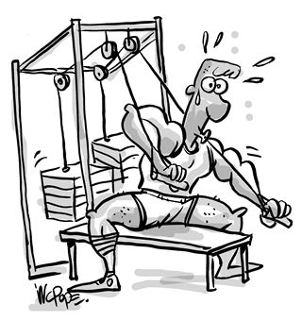 | hospital
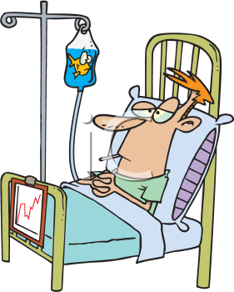 | theatre
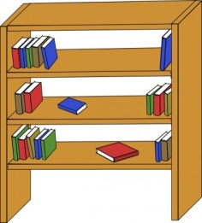 | outdoor concert
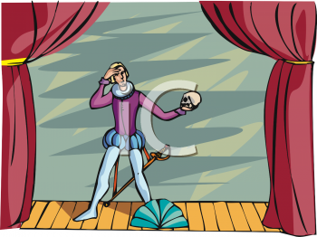 | cinema
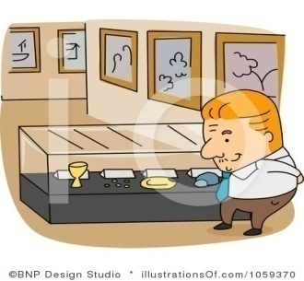 | fitness gym
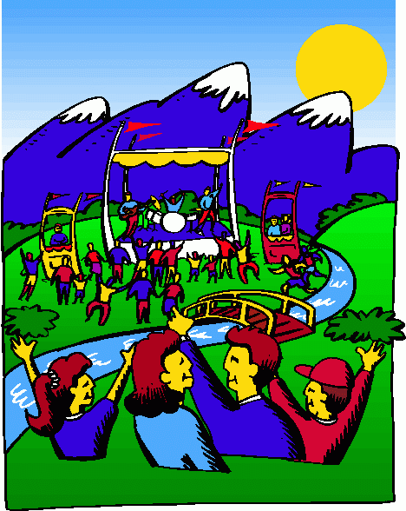 | company
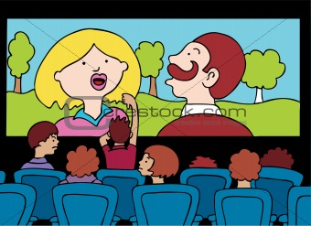 | exhibition
 | library

C) Match these descriptions with the places above

1. ____________
You can visit them with people who are interested in the same things. There are a lot of kinds of them. You can find there skeletons, photos, pictures, old tools etc.
2. ____________
If you want to feel much better and healthier, visit the place where you can stretch your body.
3. ____________
They are good for people who love live music however they usually depend on the weather.
4. ____________
You can buy a lot of cola and popcorn and watch a movie of your choice there
5. ____________
Are you looking for a job? Visit the place where you can leave your CV and impress the people around you with your abilities. You may be successful and rich one day
6. ____________
If you´d like to read a good book which you cannot find in your bookcase, visit the place.
7. ____________
Do you like costumes? Visit the place where you can see a lot of them but don´t forget to dress up.
8. ____________
If you need to heal something, you will be sent there for sure.

D) Match the pictures with the correct expression

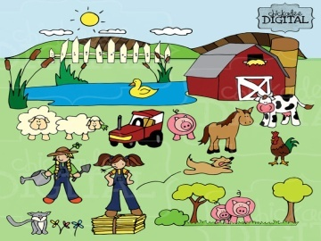 | forest
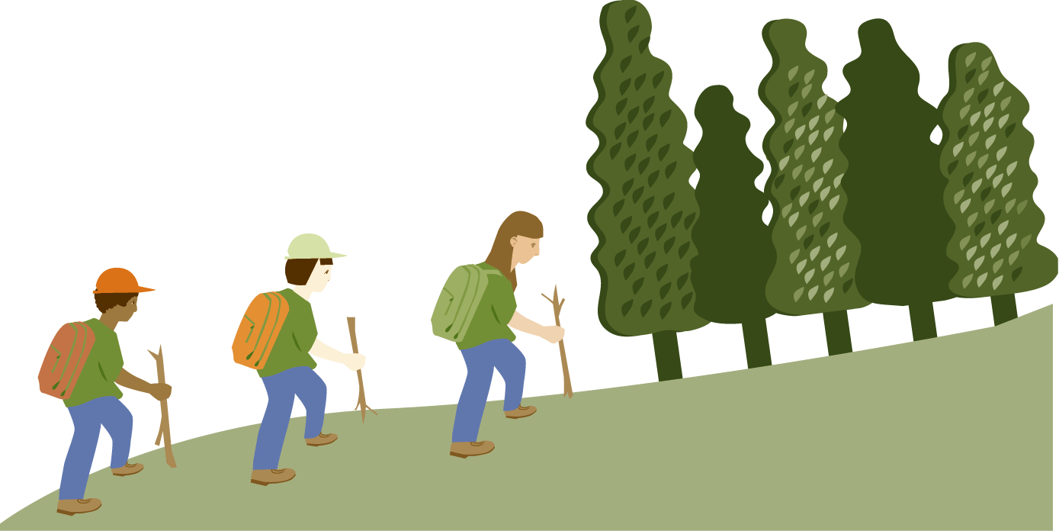 | wine cellar
 | pub
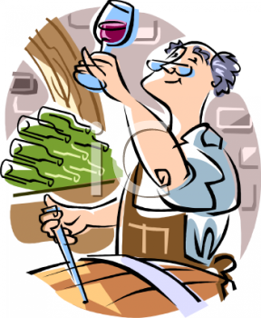 | castle
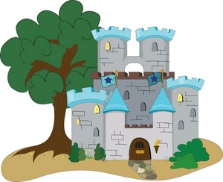 | orchard
 | pond
 | farm
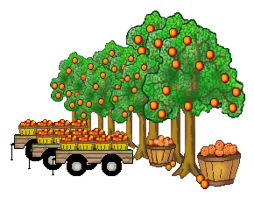 | church

E) Match these descriptions with the places above

1. ____________
It is time to go there and pick up all the fruits when the autumn comes.
2. ____________
You are welcome there if you believe in god and you need to pray for anything
3. ____________
There is a lot of work there but if you like feeding animals and looking after them, it´s a right place for you.
4. ____________
You should go there anytime you want to stay in a quiet place. You can fish there.

5. ____________
This is a good place for meeting with your friends every evening, especially when the winter comes.
6. ____________
This is a perfect place for everybody who loves history. You can visit the place and imagine people lived then.
7. ____________
This is a perfect place for hiking, observing animals, taking a deep breath and relaxing
8. ____________
It´s very warm there when winter comes, moreover, you can taste the wine you have made yourself

Zdroje:
1. Air Force illustrations. Westover [online]. 2011 [cit. 2012-10-17]. Dostupné z: <http://www.westover.afrc.af.mil/art/mediagallery.asp?galleryID=2187&?id=-1&page=1&count=48>

2. Fish. Clipartpal [online]. [cit. 2012-10-17]. Dostupné z: <http://www.clipartpal.com/clipart/animal/fish_167682.html>

3. Furniture library shelves books. All-free-download [online]. [cit. 2012-10-17]. Dostupné z: <http://all-free-download.com/free-vector/vector-clip-art/furniture_library_shelves_books_clip_art_23021.html>

4. Theater. Clipartpal [online]. [cit. 2012-10-17]. Dostupné z: <http://www.clipartpal.com/clipart/entertainment/theater_155355.html>

5. Museum. Illustrationsof [online]. [cit. 2012-10-17]. Dostupné z: <http://www.illustrationsof.com/royalty-free-rf-museum-clipart-illustration-by-bnp-design-studio-stock-sample-1059370.jpg>

6. Outdoor concert. Clipartheaven [online]. [cit. 2012-10-17]. Dostupné z: <http://www.clipartheaven.com/show/clipart/music/entertainment/outdoor_concert_1-gif.html>

7. Bad movie experience. Crestock [online]. [cit. 2012-10-17]. Dostupné z: <http://www.crestock.com/image/2226585-Bad-Movie-Experience.aspx>

8. Call center of a big company. Picturesof [online]. [cit. 2012-10-17]. Dostupné z: <http://www.picturesof.net/pages/080909-024197-398042.html>

9. Farm. Etsy [online]. [cit. 2012-10-17]. Dostupné z: <http://www.etsy.com/listing/110533420/farm-clipart-farmer-cow-horse-pigs-and>

10. Forest. Bestclipartblog [online]. [cit. 2012-10-17]. Dostupné z: <http://bestclipartblog.com/28-forest-clip-art.html/forest-clip-art-11>

11. Pond. Bestclipartblog [online]. [cit. 2012-10-17]. Dostupné z: <http://bestclipartblog.com/27-pond-clip-art.html/pond-clip-art-6>

12. Wine maker testing wine. Clipartguide [online]. [cit. 2012-10-17]. Dostupné z: <http://www.clipartguide.com/_pages/0511-0902-2318-5431.html>

13. Fairytale castle. Pamsclipart [online]. [cit. 2012-10-17]. Dostupné z: <http://www.pamsclipart.com/clipart_images/fairytale_castle_0515-0810-2213-2707.html>

14. Ovchynnikov, O. Beer mugs drink alcohol pub party. 123rf [online]. [cit. 2012-10-17]. Dostupné z: <http://www.123rf.com/photo_11852271_beer-mugs-drink-alcohol-pub-party.html>

15. Church. Bestclipartblog [online]. [cit. 2012-10-17]. Dostupné z: <http://bestclipartblog.com/26-church-clip-art.html/church-clip-art-5>

16. Peachey, Jean B. Orange orchard. Clipartmountain [online]. [cit. 2012-10-17]. Dostupné z: <http://clipartmountain.com/clipart1/otorchard5.htm>

