Enter your answers in the gaps. When you have entered all the answers, click on the "Check" button.

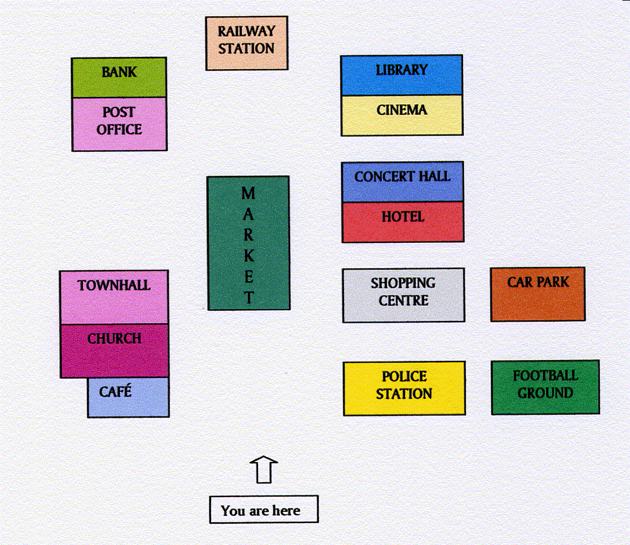
at the end behind between in in front of next next to on opposite

1.The railway station is at the end of the road, the bank and the library.
2.The bank is at the end of the road on the left-hand side and the library.
3.The library is [?] of the road, on the right-hand side and opposite the bank.
4.The post office is on the left-hand side, opposite the cinema and to the bank.
5.The concert hall is between the cinema and the hotel the right of the street.
6.The shopping centre is the town hall and in front of the car park.
7.The police station is the first building on the right, [?] the football ground, opposite the café.
8.The football ground is on the right, the police station.
9.The café is the first building on the left, [?] the church.
10.The market is the middle of the street.

Check

