Výsledky DÚ č. 4
Učebnice str. 54:
Cv. 2
- Games console
- Camcorder
- Digital photo frame
- Digital radio
- Satnav
- MP3 player
- Tablet PC
Cv. 4
- Ebook reader
- Hard disk recorder
- Satellite TV
- Notebook
- Smartphone
- HD TV
Cv. 5
- Pick upemail; play music; surf the Net; watch films; charge the battery; store photos; download a book
- Record/rewind/pause a programme; watch films
- Play music; charge the battery; store photos
- Download a book; charge the battery
- Find the way
PS str. 50:
Cv. 1
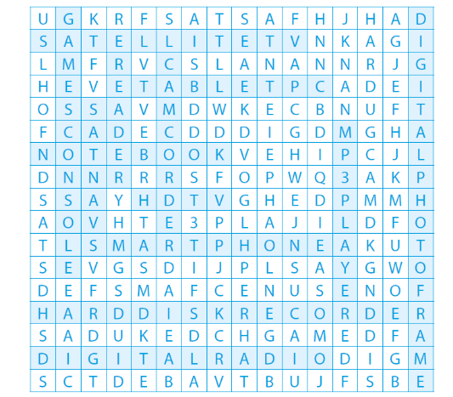
Cv. 2
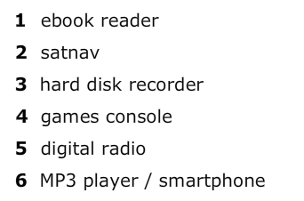
Cv. 5
