[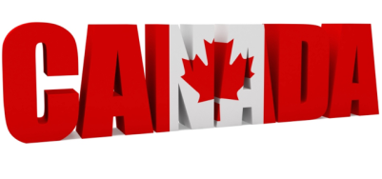](http://fredericgonzalo.com/en/2013/07/01/canada-tourism-the-downward-spiral-continues/)

I Decide whether the statements are true (T) or false (F)

1 Canada is the second-largest country in the world.

2 The head of the country is the President.

3 Canadian English is the only official language spoken in Canada.

4 The name „Canada“ comes from the word „kanata“ meaning „village“ or „settlement“.

5 The capital of Canada is Toronto.

6 The main symbol of Canada is maple leaf.

7 Canadian crown is the money that is used in Canada.

II Read the article and match the words in bold with the pictures

Canada is the second-largest country in the world, after Russia. It is located in North America and it consists of 10 provinces and 3 territories.

The head of the state is **Queen Elizabeth II** and she is represented by the Governor General.

Canada has got two official languages. They are English and French so that citizens have the right to speak either English or French in court and other public institutions.

Besides these, other languages are spoken there, for example: Italian, Chinese, German Polish, Dutch and there are even some native languages such as Algonquian.

The name Canada comes from the old word „kanata“, meaning „village“ or „settlement“ which was used by the aboriginal peoples.

Canada´s national symbol is the maple leaf and the symbol can be seen on the **Canadian flag** and on the **penny**. There are other national symbols mainly animals that typically live in Canada. They are the **beaver** and the **Canada Goose**.

Canada´s official national sports are ice hockey and **lacrosse**. Other popular spectacle sports include curling and **Canadian football**.

The currency that is used in Canada is **Canadian dollar**.

Canada´s capital city is Ottawa, but the largest city is Toronto.

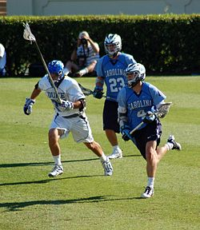 Vertical triband (red, white, red) with a red maple leaf in the centre 