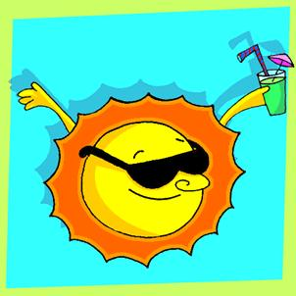
CLIMATE AND SEASONS
The climate of the earth depends on the intensity of the sun’s rays. This intensity varies in different parts of the year and in different parts of the planet.
The planet is not perfectly vertical in this axis. For this reason the northeast hemisphere receives the rays of the sun more directly in the months of June, July and August. These months are warm in this part of the Earth. It is “summer”.
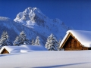
On the contrary, in the months of December, January and February, the rays of the sun fall indirectly in this hemisphere. These months are very cold. To the north of the Tropic of Cancer there is snow in the winter.
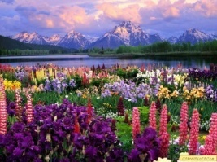
The other months are periods of transition. In the months of March, April and May the flowers come out and the babies of animals are born. There is abundant rain, and the snow smells in the mountains. The rivers are big and fast. This season is called spring. In the months of September, October and November the air is cold again. The leaves of the trees fall to the ground and the wind blows hard. This season is autumn, or fall. In the zones near the Equator the climate is warm all year round. Climatic variations depend on altitude and other factors.

Read the text to find the following data. Concentrate only on the parts which are relevant for completing the table. Do not use the dictionary.
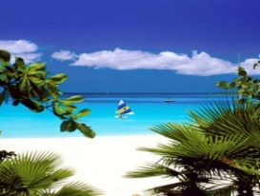 | depends on the intensity of the sun’s rays.
There is winter in the months of
 | The flowers come out
The intensity varies in different | 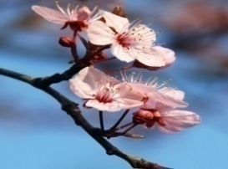
 | Is not perfectly vertical in this axis.
The months of December, January and  February. | 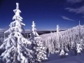  are
In spring; the rivers are
 | In this season the leaves of the trees fall to the grown.
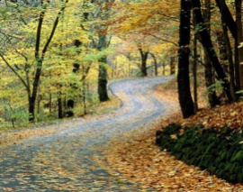 | Depend on altitude and other factors.
In the zones near the Equator the climate is

Discuss the statements
- What season of the year do you like more? Why?
- In what month of the year do you feel more the rays of the sun? Why?
- If you can change the order of the seasons, what order will you give? Why?
- What do you suggest to prevent the global warming? Why?
- Would you like Colombia has the four seasons? Why?
- What activities do you do in summer?
- What activities do you do in winter?

