Interesting facts about the USA
Student A  The United States dollar is the official currency of the United States of America. It is divided into 100 cents.  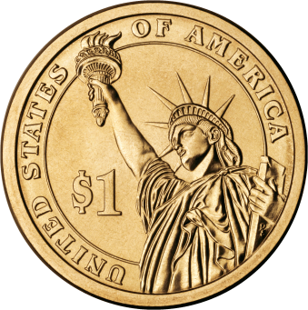  Etymology of this word:  In the 16th century, Count Hieronymus Schlick of Bohemia began minting coins. The valley where the silver was mined is now known as Jáchymov, which was previously known as Joachimstaler later shortened to the German Taler. This German word was eventually transferred into English dollar.  The word "buck" (doláč, babka) is often used in colloquial (hovorová) English. | Student B  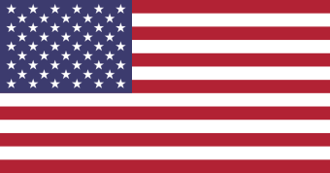  The national flag of the United States of America is often simply called the American flag. It consists of thirteen horizontal red and white stripes, with a blue rectangle which has fifty small, white stars. The 50 stars on the flag represent the 50 states of the United States of America and the 13 stripes represent the thirteen British colonies that declared independence (vyhlásily nezávislost) from the Kingdom of Great Britain. Nicknames for the flag include the "Stars and Stripes" and "The Star-Spangled Banner" which is also the name of the national anthem (národní hymna). The flag is usually flown at most public buildings.
Student C  The White House is the official residence of the President of the United States of America, and is located in Washington, D.C., the capital city of the USA (D.C. stands for the District of Columbia named after Christopher Columbus – it is not a state). The first US President to live in the White House was John Adams (the second President of the USA). However, the construction of the House had begun during the presidency of George Washington (the first US president- who had not lived there) During the War of 1812, the British set fire to the President’s House in 1814. Nearly all of the interior was destroyed by the fire. There is a legend that says that the House was called the White House when it was rebuilt and when its fire-blackened surfaces were painted white (over the original grey) 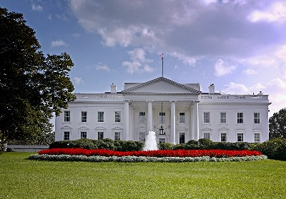 | Student D  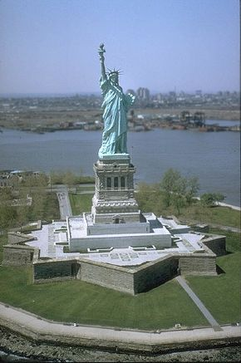  The Statue of Liberty is a huge sculpture that is located on Liberty Island in New York. This monument was a gift to the USA from the people of France. It represents a woman who is escaping the chains of tyranny (the broken chains lie at her feet). The statue holds a torch that is a symbol of liberty. Liberty was designed by the French sculptor Frederic Auguste Bartholdi. The statue was built in France and was brought to the USA in pieces on a French ship. The statue was re-assembled in the USA .  The seven rays of Liberty's crown symbolize the seven seas and seven continents of the world. Liberty holds a tablet in her left hand that reads "July 4, 1776" (written in Roman numerals, MDCCLXXVI), which is Independence Day of the United States of America.
T/ F statements  1The word „buck“ means a „cent“ in American English.  2 There are 12 horizontal stripes on the flag of the US and they represent the oroginal British colonies.  3 The nickname for the flag is the same as the name of the US national anthem.  4 The White House is located in the state of Washington.  5 The first president who lived in the White House was George Washington.  6 The Statue of Liberty was given tp the USA by the French nation.  7 The date written on the tablet comemmorates the date of the independence of the USA.  Answer the questions  1 What is the etymology of the word „dollar“?  2 What does the American flag look like? What do the parts represent?  3 Where is the White House located?  4 Why is the White called the White House?  5 Where is the Statue of Liberty situated?  6 What does the Statue represent? | T/ F statements  1The word „buck“ means a „cent“ in American English.  2 There are 12 horizontal stripes on the flag of the US and they represent the oroginal British colonies.  3 The nickname for the flag is the same as the name of the US national anthem.  4 The White House is located in the state of Washington.  5 The first president who lived in the White House was George Washington.  6 The Statue of Liberty was given tp the USA by the French nation.  7 The date written on the tablet comemmorates the date of the independence of the USA.  Answer the questions  1 What is the etymology of the word „dollar“?  2 What does the American flag look like? What do the parts represent?  3 Where is the White House located?  4 Why is the White called the White House?  5 Where is the Statue of Liberty situated?  6 What does the Statue represent?
T/ F statements  1The word „buck“ means a „cent“ in American English.  2 There are 12 horizontal stripes on the flag of the US and they represent the oroginal British colonies.  3 The nickname for the flag is the same as the name of the US national anthem.  4 The White House is located in the state of Washington.  5 The first president who lived in the White House was George Washington.  6 The Statue of Liberty was given tp the USA by the French nation.  7 The date written on the tablet comemmorates the date of the independence of the USA.  Answer the questions  1 What is the etymology of the word „dollar“?  2 What does the American flag look like? What do the parts represent?  3 Where is the White House located?  4 Why is the White called the White House?  5 Where is the Statue of Liberty situated?  6 What does the Statue represent? | T/ F statements  1The word „buck“ means a „cent“ in American English.  2 There are 12 horizontal stripes on the flag of the US and they represent the oroginal British colonies.  3 The nickname for the flag is the same as the name of the US national anthem.  4 The White House is located in the state of Washington.  5 The first president who lived in the White House was George Washington.  6 The Statue of Liberty was given tp the USA by the French nation.  7 The date written on the tablet comemmorates the date of the independence of the USA.  Answer the questions  1 What is the etymology of the word „dollar“?  2 What does the American flag look like? What do the parts represent?  3 Where is the White House located?  4 Why is the White called the White House?  5 Where is the Statue of Liberty situated?  6 What does the Statue represent?

This worksheet is for pre-intermediate students. In the first part - there are 4 texts about the US most famous symbols (about dollar, the flag, the White House and the Statue of Liberty) First of all distribute the sheets with True and False statements and questions. Ask students to decide whether the statements are true or false. Then distribute the texts to students - they should be divided into groups of 4 students (Student A,B,C,D) These students should then read the texts for themselves and then they shoud report to the other students in the group what they have learned. Then the T/F statements should be checked as well as the questions.

