Making arrangements
- Let´s swim in the pool!
- Why don´t we swim in the pool?
- What about swimming in the pool!
- Shall we swim in the pool?
- Would you like to swim in the pool?
- Would you mind swimming in the pool?
- Shall I swim with you in the pool?

Let´s practise!

1.You know that there is a good thriller on in the cinema. You don´t want to go alone. You ask your friend.
What ………………………………………………………………………………………..?
2. There is open a new salsa club. You want your boyfriend to attend these lessons with you.
Why ………………………………………………………………………………………..?
3.You like having fun. So you thinf that karaoke could be really funny. You ask your friends:
Shall ………………………………………………………………………………………..?
4.You want to surprise your girlfriend. So you invite her to eat out. But you have booked the restaurant only for you and your girlfriend.
Would..............mind………………………………………………………………..?
5.Your sister is cooking. You want to help her. So you ask:
Shall………………………………………………………………………………………………?
6.You can see your neighbour carrying a lot of boxes and a bag. What do you say?
Shall……………………………………………………………………………………………….?
7.You and your friend decided to go shopping. You need some help to choose the correct piece of clothes for you.
Would……………….mind…………………………………………………………………..?
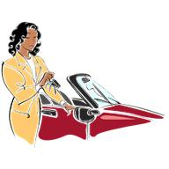 | 8.You have an appointment with your boyfriend but he is late. You aren´t sure if to wait for him.  Shall…………………………………………………………………………………………………?
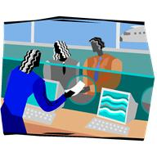 | 9.You are at the airport. Your wife is nervous to be late. So she asks:  Would ……………………….mind………………………………………., darling?
10.You are at a party of your colleague. You are congratulating to him. And you want someone to take a photo of you. So you ask:
Why …………………………………………..………………………………..…….?
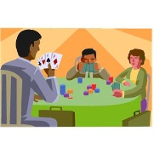 | 11.You want to play cards with your friends so you ask them:  Would………………………like…………………………………………..………?
12.Your wife is in hospital. You are going to visit her and to stay at her for a while. You have also a bunch of flowers for her.
Would…………………………..mind…………………………………..……….?
13.You are on your holidays at sea. You feel wonderful and you want to sunbathe there. So you say:
Let´s ………………………………………………………………………..…………?
14.You are going for a business trip. Your husband is accompaigning you. The train has just arrived. You want to say good bye to each other.
Let´s……………………………………………………………………………..……..?
15.Finally you can have holidays. You want to go climbing because you love mountains.
What…………………………………………………………………………………….?
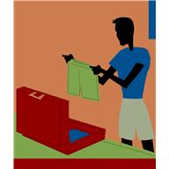 | 16.You are packing your suitcase. You want to be sure if to take green trunks with you so you ask:  Shall…………………………………………………………………………….…………?
17.You know it is raining. But your dog needs to be taken for a walk.
Let´s……………………………………………………………………………………….?
18.You adore winter sports. So you ask your boyfriend to go with you.
Would………………………..like……………………………………………………..?
19.You had a really difficult day at work. You are calling to your friend to say that your meeting will be tomorrow.
Would…………………………..mind………………………………………………..?
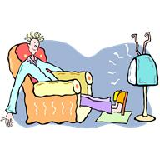 | 20.Your husband is watching TV but it is too loud. You ask him to tur nit down.  What………………………………………………………………………………………..?

