United States of America – the USA
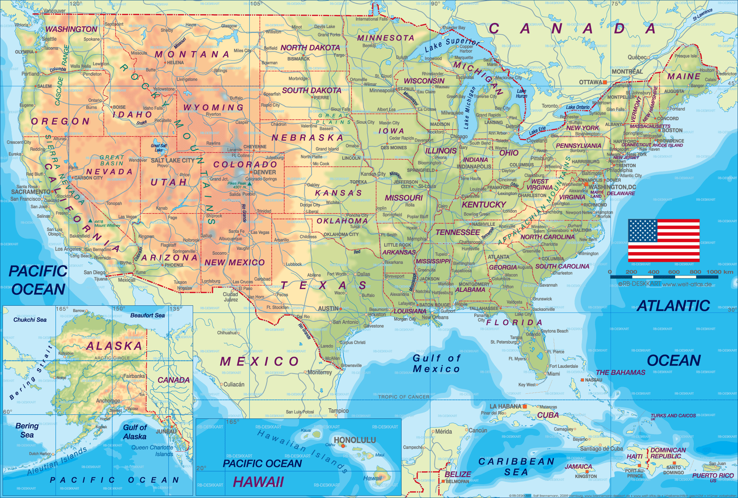

The USA is the fourth biggest country in the world after Russia, China and Canada. It has the Atlantic Ocean in the east and the Pacific Ocean in the west. USA is so big that it has four different time zones, so when it is 3 o’clock in New York on the east coast, it is 12 o’clock in Los Angeles on the west coast.
Fast facts
Capital city: Washington DC
Biggest city: New York City; about 8,5 million inhabitants
Population: about 322 million people
Money: US Dollars (USD)
Highest mountains: Mount McKinley 6194 m, Mount Whitney 4418 m
Longest river: Missouri River 4090 kilometres
Largest lake: Lake Michigan

The USA has 50 states, 48 states in the same place and two separate states, Alaska in the north, next to Canada, and Hawaii in the Pacific Ocean. Every state has its’ own capital city. The national capital is Washington DC.

The USA has many different names, such as America, the States, the Union, and “Uncle Sam”. “Uncle Sam” comes from posters during the Second World War.

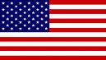
The American flag is called “Stars and Stripes”. Red stands for courage, blue for justice and white for liberty. The 13 stripes symbolize the original 13 colonies that were created by European settlers. The 50 stars symbolize the 50 states of today.

Nature
At the border between USA and Canada lie 5 big lakes right next to each other. They are called the Great Lakes and consist of Lake Superior, Lake Michigan, Lakes Huron, Lake Ontario and Lake Erie. The lakes are linked together by the Saint Lawrence River. The lake area is the biggest freshwater area in the world.
Tundra state: Alaska
Forest states: Minnesota, Wisconsin, Michigan, Maine, Vermont
Mountain states: Washington, Montana, Idaho, Oregon, Colorado
Prairie states: Kentucky, Arkansas, Missouri, Indiana, Texas
Desert states: Nevada, Californa, Arizona, New Mexico
“Sunny” states: Florida, Georgia, Alabama, (Hawaii)

The climate is very different in different parts of the USA. In the north part of Alaska the ground is frozen all year round. The ground is called tundra. No trees grow on the tundra, only small bushes.
South of the tundra it rains regularly and there are big deciduous forests and pine forests. Between the Rocky Mountains and the Appalachians one can find massive grass plains. It doesn’t rain that much so the ground is dry. Here crops like wheat and corn are grown. This area is called the Great Basin. The ground nearest the Rocky Mountains is dry and many people work with cattle farming. This is called the prairie. West of the Rocky Mountains it is very dry and one can’t grow crops or raise cattle. The desert has taken over. Here you only see grass, bushes and cactuses.
In the south, by the Mexican Gulf, it is hot and damp all year round.

Politics
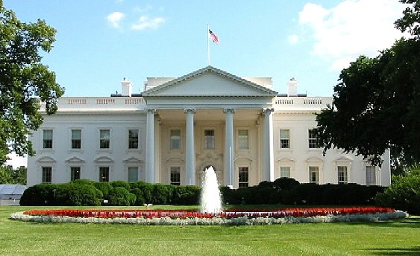
The USA is a republic; they don’t have a king but a president. The president is elected by the people every four years. The president’s official home and office is the White House in Washington DC. It is an enormous mansion with 132 rooms. The most famous of them is the Oval office, the president’s own office. The current president is democrat Barack Obama.

Every state has its own government. It is responsible for laws about local issues like, highways, education and housing. The national government in Washington DC, is lead by the President, and is responsible for laws that affect all the people. They are laws such as civil rights and national security.

There are two major parties in the USA, the Republicans and the Democrats.
George Bush, Abraham Lincoln and Richard Nixon are all examples of Republican presidents. John F. Kennedy, Jimmy Carter and Bill Clinton have all been Democratic presidents.

History
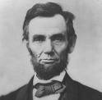
Between 1861 and 1865 there was a civil war in America. It was between the northern and the southern states. They fought because the states in the north thought that slavery was cruel and unnecessary. The states in the south needed the slaves to pick cotton on the big plantations. The soldiers from the northern states had better equipment than the soldiers from the south. In the end of the war many soldiers from the south didn’t have guns, ammunition and food. Some of them even marched barefoot. In the end the northern states won. About 620,000 people died in the Civil War. The president in the northern states at that time was Abraham Lincoln.
He and his government passed a law that abolished slavery in 1865. This has made President Lincoln to one of the most loved and known American presidents. That same year, 1865, President Lincoln was murdered by a man from the south.

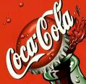
Industry
Because of natural resources like oil and minerals USA is one of the largest industry countries in the world. No other country has as many factories as USA. Most of the products are sold within the country but USA is also the country that has the biggest export industry in the world. Detroit has a big car industry. In Silicon Valley in California you can find a lot of computer companies. Wall Street at Manhattan in New York City is the country’s financial centre. Wall Street is the home of the American stock market. Many companies had their offices in World Trade Center before 9/11.

Some major American companies are Ford, the Coca Cola Company, Microsoft, Apple Inc, Yahoo, Skype, Pizza Hut, and Nike.

School and Education
School are compulsory for all children in USA. Most children start Kindergarten when they are five or six years old. After Kindergarten the children start first grade. Grades 1 to 6 are called Elementary school. Grades 7 to 9 are called Middle school or Junior High. Senior High is from grade 10 to grade 12. Most children finish compulsory school by the age of 18.
Grade 9: freshmen
Grade 10: sophomores
Grade 11: juniors
Grade 12: seniors
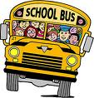
There are about 126,000 public and private school in the States.

More and more schools have school uniforms. By forcing all students to wear them gang members can’t use their symbols. The uniforms also stop the teenagers from spending a lot of money on designer clothes. They also keep people from stealing from each other’s clothes. People have even been killed because of their expensive clothing.

School is more than just studying. There are usually an orchestra, a choir, a chess club, a computer club and an athletics team. Almost all schools have football and basketball teams. The games are very important and play an important role in society.

After High School many student go to college or the university. There are about 600 public and 1,600 private collages in the US. The private are often very expensive. Some parents start saving money as soon as their children are born. On average, college cost $16,500 a year. Even though it is very expensive to go to college many parents want their children to study. It is considered the key to a successful life.

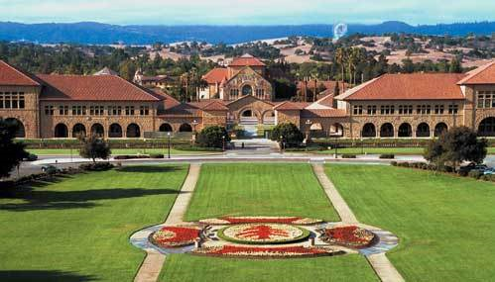
Some of the most famous universities in the world are located in the States. Harvard, Stanford, MIT and Yale are some examples.

Yale University in California →

Some short Facts
Some of the most famous and biggest cities in the world lie in the USA. On the east coast lie cities such as New York, Philadelphia and Washington DC. On the west coast are the biggest cities Los Angeles and San Francisco. New York is the big fashion city of the country while LA is known for Hollywood and its big movie industry.

USA is a rich country with many rich people. But still, 10% of the population is very poor and often live in the slum areas. The difference is often easy to see in the big cities where the rich live in nice parts of the city and the poor in the slums. Harlem in New York is an example of a large slum area.

The music industry is also big in the USA. Artists like Michael Jackson, Britney Spears and Justin Timberlake come from the USA. Groups like Green Day, Linkin Park and Nirvana are American. Country singing is also very big in USA and artists like Dolly Parton, Taylor Swift and the Dixie Chicks are very popular. Nashville is the capital city for all the country artists.

Some of the most famous and read writers come from the USA. Mark Twain (1835-1910) wrote The Adventures of Tom Sawyer and The Adventures of Huckleberry Finn. Ernest Hemingway (1899-1961) wrote books like Death in the Afternoon and The Sun also Rises and won the Nobel Prize in 1954. Joyce Carol Oates is very much read and has written books, plays and poetry. Nowadays books written by Dan Brown and Stephenie Meyer are read all over the world.

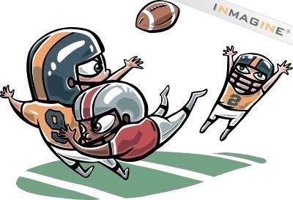
The USA has many good sports men and sports women. Some of the biggest sports are baseball, basketball, ice hockey and American football. The hockey league, NHL, is one of the best in the world. The same can be said about NBA, the basketball league and NFL, the football league. Americans are also good at athletics, especially when it comes to running short distances like 100, 200 and 400 meters.

Tasks

- Translate the underlined words. Make a wordlist.

- Answer the following questions

- What countries are bigger than the USA?
- How many time zones are there in America?
- How many states are there in the USA?
- What two states are not together with the others?
- What is the capital city of the USA called?
- What is the American flag called?
- What do the colours red, blue and white stand for?
- What is the Great Basin?
- Explain the words tundra, prairie, and desert.
- How often do the Americans elect a new President?
- What is the White House?
- What is the president’s office called?
- What are the two major parties called?
- Name two Republic and two Democratic presidents.
- Who fought in the Civil War?
- What was the reason for the Civil War?
- Why is Abraham Lincoln one of the best known American presidents?
- Where should you be if you want to work at a computer company in the States?
- Name two major companies from the US.
- Name one big city on the east coast and one of the west coast.
- What is the name of the large slum area in New York?
- Between what grades do you go to Elementary school?
- How much does it cost to go to college?
- Name two famous universities in the States.
- Name three music artists/groups from the states.
- Name one famous American writer.
- Name three big sports in America.

Subjects: (Look for Facts on the Internet and from books you get from your teacher.)
- The American South (Texas, Louisiana, Alabama Etc, the Mississippi River)
- Florida (Everglades, Disneyland Etc.)
- Nature and wildlife in Canada
- The Great Lakes + Niagara Falls
- Alaska
- Rocky Mountains and Yellowstone
- Big cities in USA (Washington DC, New York City, Los Angeles)
- Big cities in Canada (Toronto, Vancouver, Montreal)
- Major companies (Disney, Coca Cola, Microsoft)
- Hawaii
- Olympic Games in North America

Make a poster on your subject.

